**Views:**

1. View workers and which center they work at

create view workers_center as

select *

from donationcenters inner join workers using (center_id) inner join employees using (worker_id);

2. View the locations of churches

create view church_location as

select *

from donationcenters inner join ziplocations using (zip_code)

where center_type like '%Church%';

3. View foods and their allergens

create view allergen_foods as

select *

from foods inner join foodallergens using (donation_id);

4. View physical donations

create view phys_don as

select *

from donations inner join physicaldonations using (donation_id);

5. View monetary donations

create view mon_don as

select *

from donations inner join monetarydonations using (donation_id);

**Queries:**

1. # Find the cities with the greatest number of donation centers

select city, count(zip_code) as num

from ziplocations inner join donationcenters using (zip_code)

group by city

having num = (

select max(y.num) as max

from (

select count(zip_code) as num

from ziplocations inner join donationcenters using (zip_code)

group by city) y);

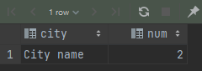

2. # Find the cities with the largest number of donations

select city, count(zip_code) as num

from ziplocations inner join donationcenters using (zip_code) inner join donations using (center_id)

group by city

having num = (

select max(y.num) as max

from (

select count(zip_code) as num

from ziplocations inner join donationcenters using (zip_code) inner join donations using (center_id)

group by city) y);

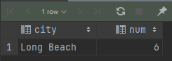

3. # Find all of the pairs of employees who work at the same donation center

select a.first_name as "Employee 1 FN",

a.last_name as "Employee 1 LN",

b.first_name as "Employee 2 FN",

b.last_name as "Employee 2 LN",

a.center_id as "Employee 1 Center",

b.center_id as "Employee 2 Center"

from workers_center a inner join

workers_center b using (center_id)

where a.worker_id > b.worker_id;

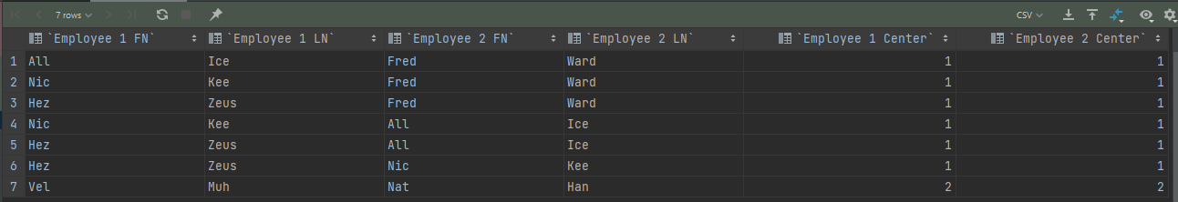

4. # List the donation centers with the amount of donations above the average

select name, count(donation) as num

from donationcenters inner join donations using (center_id)

group by center_id

having num > (

select avg(y.num) as avg

from (

select count(donation) as num

from donationcenters inner join donations using (center_id)

group by center_id) y);

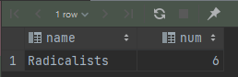

5. # Find all of the pairs of donation centers that have a state, are in the same state, and are Churches.

select a.name as "Center Name 1",

b.name as "Center Name 2",

a.center_type as "Center Type 1",

b.center_type as "Center Type 2",

a.state as "Center State 1",

b.state as "Center State 2"

from church_location a inner join

church_location b using (state)

where a.center_id > b.center_id;



6. # Find all pairs of food with the same allergen

select a.item as "Item 1",

b.item as "Item 2",

a.allergen as "Item 1 Allergen",

b.allergen as "Item 2 Allergen"

from allergen_foods a inner join

allergen_foods b using (allergen)

where a.donation_id > b.donation_id;

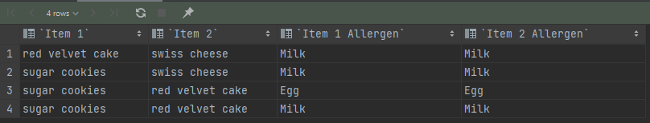

7. # Name the person who has donated the most amount of money

select distinct first_name, last_name, value

from donators inner join mon_don using (donator_id)

where value = (

select max(value)

from monetarydonations);

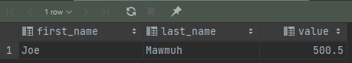

8. # Find the food with the highest number of allergens

select item as "Food", count(allergen) as "Num of Allergens"

from allergen_foods

group by Food

having `Num of Allergens` = (

select max(y.num) as max

from (

select count(allergen) as num

from allergen_foods

group by item) y);

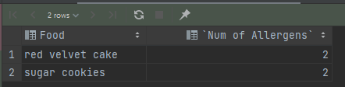

9. # List the name of everyone who donated food items and what food they donated

select first_name, last_name, item

from donators inner join donations using (donator_id) inner join foods using (donation_id);

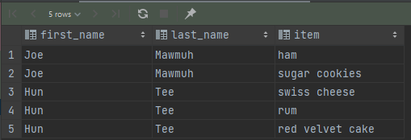

10. # List the donated items that have not yet been distributed

select donation, donation_id

from phys_don

where recipient_id is null

union

select donation, donation_id

from mon_don

where donation_id not in (

select donation_id

from moneydistributions);

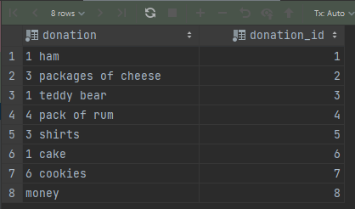

**Inserts Used:**

insert into centertypes(center_type) values

('Homeless Shelter'),

('Church');

INSERT INTO ZipLocations(zip_code, city, state, country) VALUES

(90815, 'Long Beach', 'CA', 'United States'),

(123, 'City name', 'State', 'A country'),

(92348, 'Real Town', 'CA', 'United States');

insert into ZipLocations(zip_code, city, country) VALUES

(43215, 'Best Ville', 'Japan'),

(54312, 'Worst Ville', 'Japan');

insert into donationcenters(name, street, center_type, zip_code) values

('Homelessness Help', '123 street', 'Homeless Shelter', 123),

('Needing?', '56 avenue', 'Homeless Shelter', 123),

('Radicalists', '666 blvd', 'Church', 90815),

('Chrispians', '2 blvd', 'Church', 92348),

('Baptizers', '5 blvd', 'Church', 43215),

('Missionists', '09 blvd', 'Church', 54312);

insert into workers (first_name, last_name, center_id) values

('Fred', 'Ward', 1),

('All', 'Ice', 1),

('Nic', 'Kee', 1),

('Nat', 'Han', 2),

('Hez', 'Zeus', 1),

('Vel', 'Muh', 2);

insert into employees (worker_id, hourly_wage) values

(1, 15),

(2, 15),

(3, 15),

(4, 15),

(5, 15),

(6, 15);

insert into donators(first_name, last_name, phone, street, zip_code) values

('Joe', 'Mawmuh', 0621231234, '1 street', 123),

('Hun', 'Tee', 1871234321, '5 blvd', 90815);

insert into donations(donation, date_received, center_id, donator_id) values

('1 ham', '2021-1-6', 1, 1),

('3 packages of cheese', '2021-4-7', 3, 2),

('1 teddy bear', '2011-10-3', 1, 1),

('4 pack of rum', '2021-5-11', 3, 2),

('3 shirts', '2021-8-4', 3, 2),

('1 cake', '2021-5-11', 2, 2),

('6 cookies', '2021-8-4', 3, 1),

('money', '2021-9-4', 3, 1),

('money', '2021-9-7', 3, 1);

select *

from donations;

insert into physicaldonations (donation_id) values

(1), (2), (3), (4), (5), (6), (7);

insert into monetarydonations (value, donation_id) values

(100.75, 8), (500.50, 9);

INSERT INTO Destinations(recipient, street, zip_code)

VALUES('Sue\'s Orphanage', '400 State Way', 90815), ('Joey', '400 State Way', 90815);

insert into moneydistributions (value_distributed, donation_id, recipient_id) values

(400, 9, 1), (100.50, 9, 2);

insert into brandeddonations (brand, donation_id) values

('Bucher', 1), ('swiss', 2), ('teddiesRus', 3), ('Modelo', 4), ('Nike', 5), ('Homemeade', 6), ('Homemade', 7);

insert into foods (item, best_by, donation_id) values

('ham', '2022-1-1', 1), ('swiss cheese', '2022-1-1', 2), ('rum', '2022-1-1', 4),

('red velvet cake', '2022-1-1', 6), ('sugar cookies', '2022-1-1', 7);

insert into DonationAllegens (allergen, donation_id) values

('Milk', 2), ('Nuts', 4), ('Milk', 6), ('Egg', 6), ('Egg', 7), ('Milk', 7);